Step 1 --> Open the web browser.
1. Open the web browser (Google Chrome recommended) and in the url bar, enter: admin.leoscamera.com
Note: No password is required as we are using iP verification. However if a login is ever requested, provide the following: login: leos password: leos1955
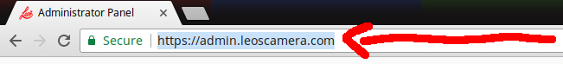
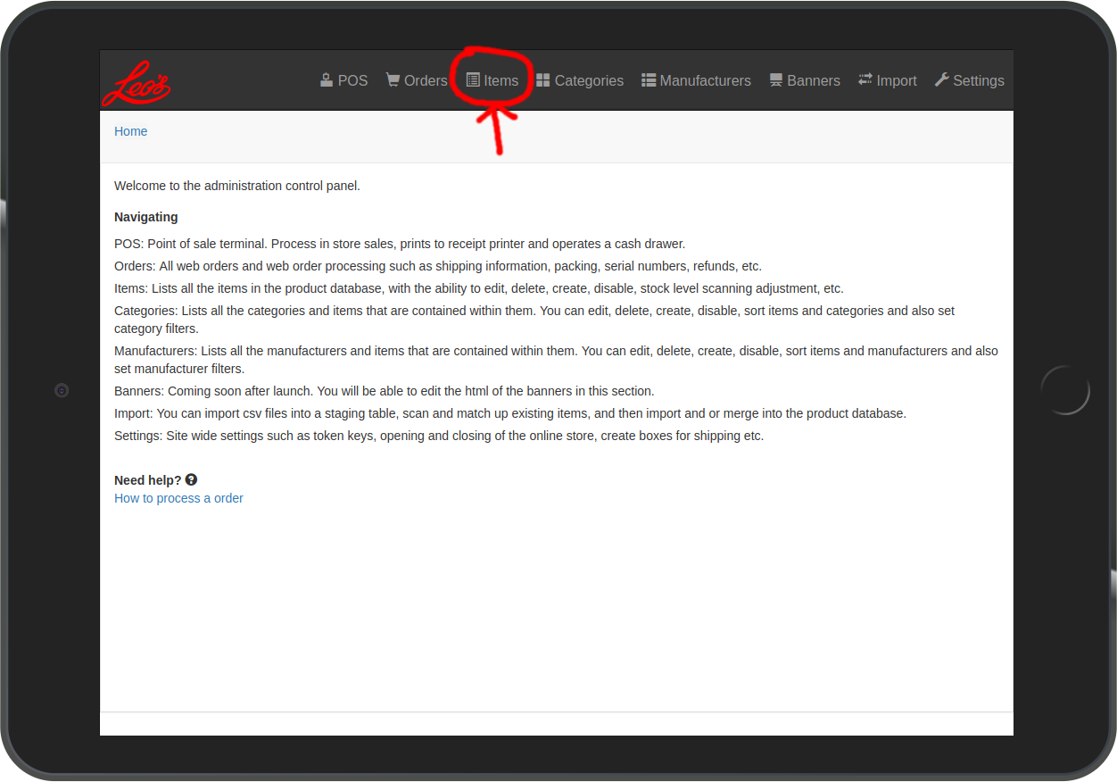
2. When the admin homepage opens, Touch on Items in the top menu bar.

Step 2 --> Items Action Menu
1. Touch the Actions button.
- Automatic stock increase: Touch Add Stock +
  - When scanning a item, each beep / scan will increase the stock value by 1.
- Automatic stock decrease: Touch Remove Stock -
  - When scanning a item, each beep / scan will decrease the stock value by 1.
- Check stock: Touch / Click Check Stock
  - In check stock mode, each beep / scan will bring a item up but no stock increase or decrease is automatically added. You have to manually touch the + or – buttons to adjust the stock levels if you wish to make adjustments.
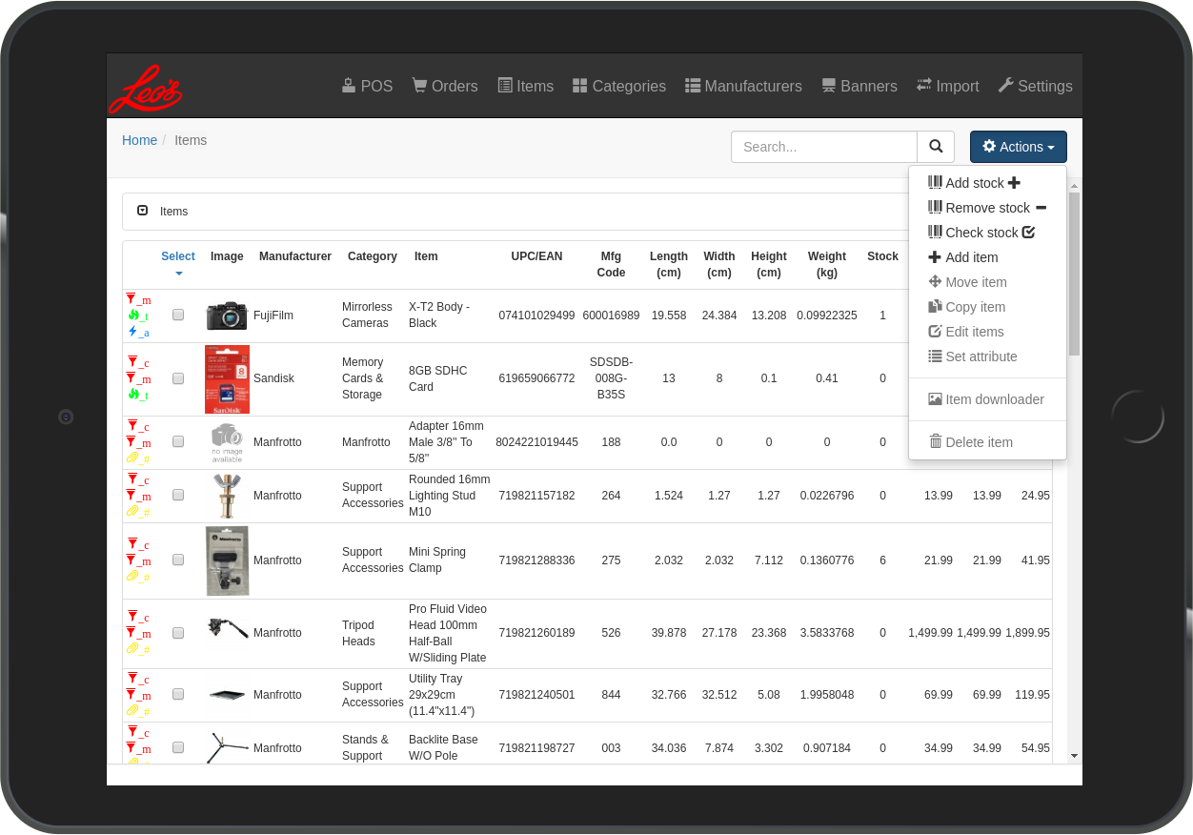
Step 2 --> Items Action Menu (cont.)
2. You can easily check which scanning mode you are in by the Header of the Scanning window after it opens.
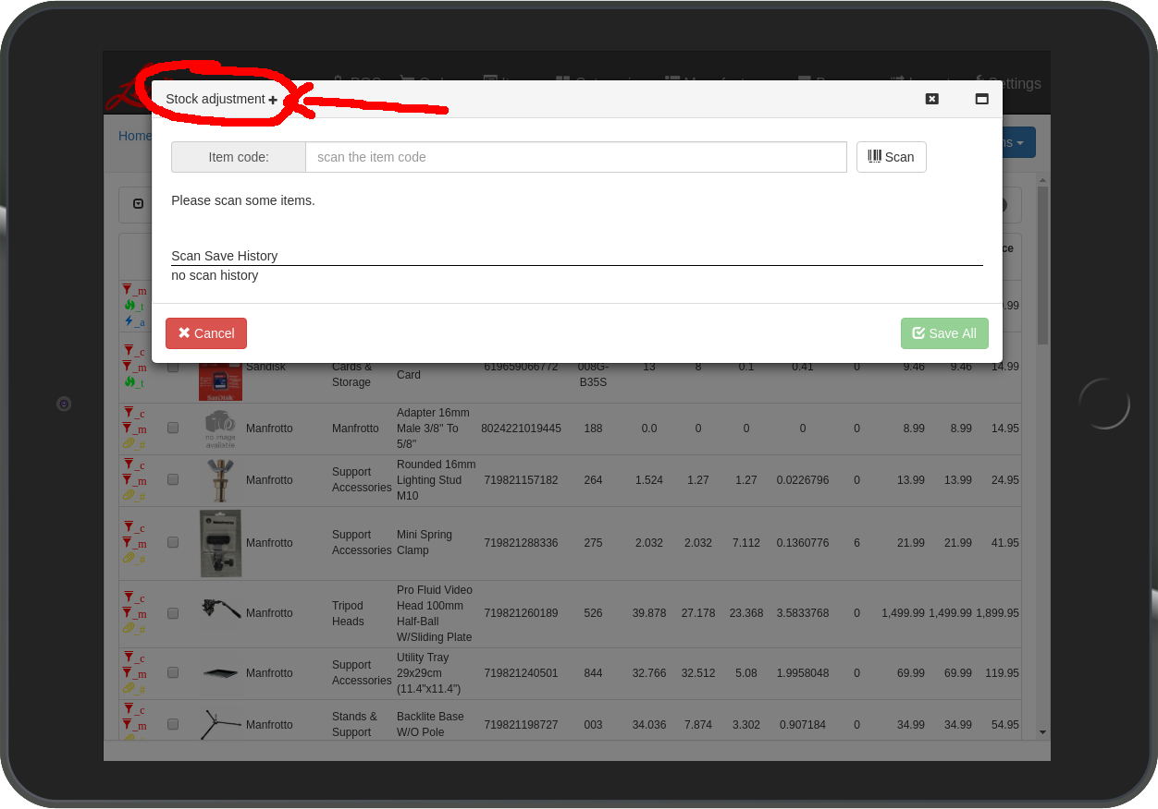
Add stock +
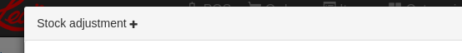

Remove stock -
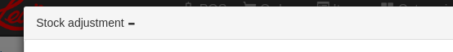

Check stock
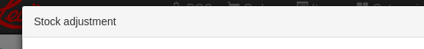

Step 3 --> Scanning
1. Scan / Beep a item, it will display in the scanning window if the item exists in the Database. The last item you scan will flash / highlight itself in Blue.
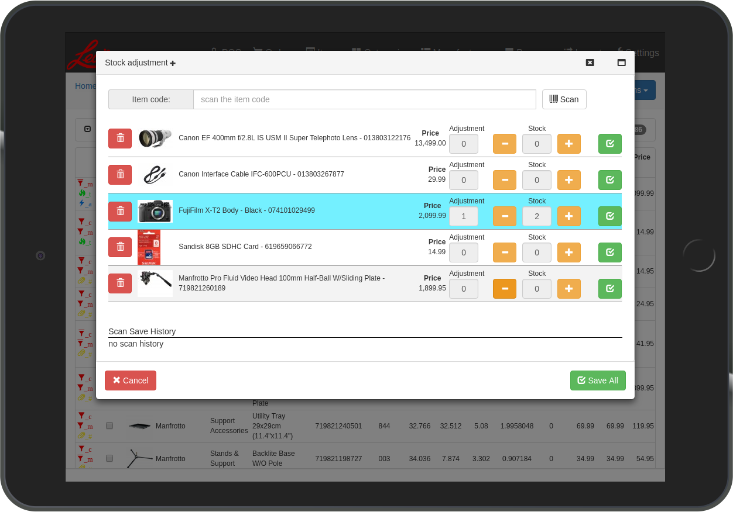

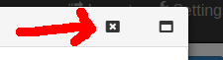
2. To exit and close the scanning window, click on the small X at the top right of the window.


3. You can full screen the window by clicking on the window icon at the top right of the window. Touch it again to bring the window back to it’s normal size.
Step 3 --> Scanning (cont.)
Scanning: Scanning / Beeping a item with the scanner will automatically input and search for the item. If the scanner has trouble reading the code, you can manually type in the code by touching the Item code: input box (scan the item code).
Once it is highlighted, you quickly double tap on the scanner trigger to open the iPad virtual keyboard. After typing the code, touch the Scan button.
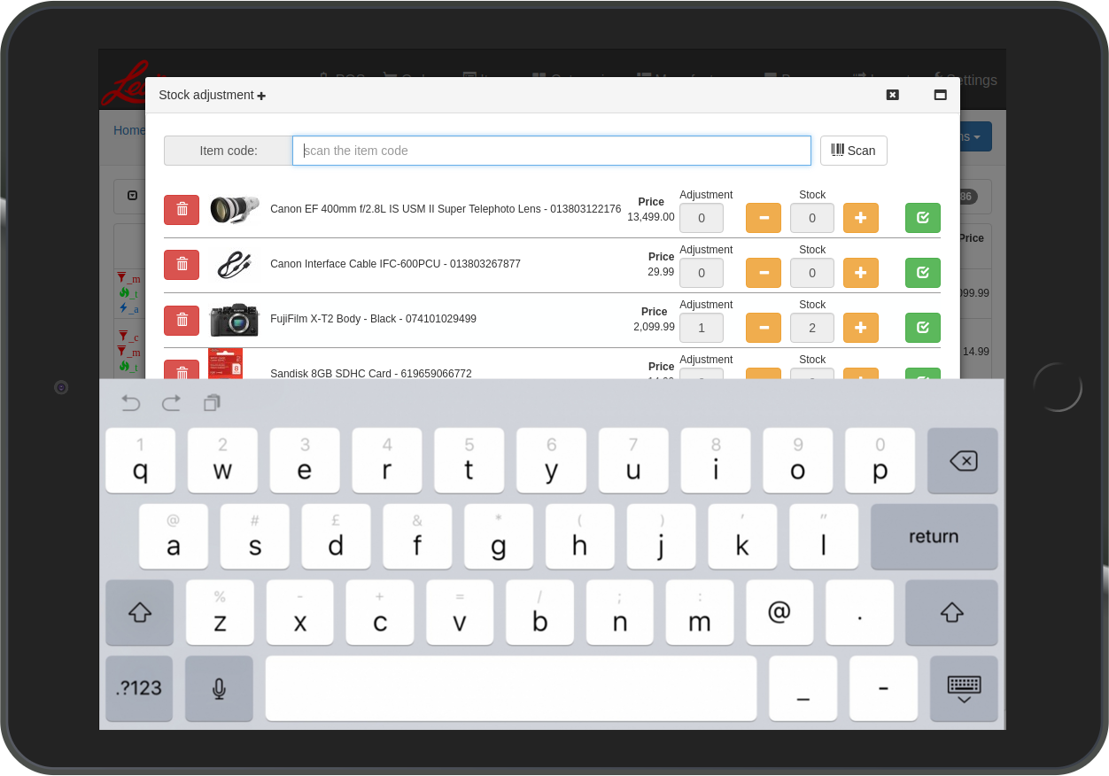
***NOTE*** --> Quickly double tap the scanner trigger to SHOW and HIDE the iPad virtual keyboard. The keyboard needs to be CLOSED / HIDDEN for the scanner to work properly.

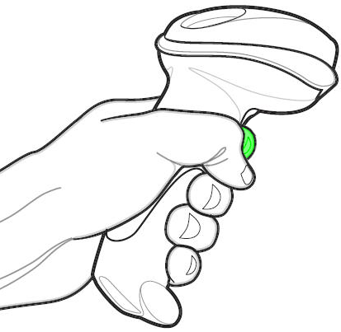

---> ---> --->
Step 3 --> Scanning (cont.)

Removing a item from the list:
- Touch the Red Trash button.
  - This will remove the individual item that was scanned from being updated. Any changes you made will not be applied to this item.

Cancelling all changes:
- Touch the Cancel button.
  - This will cancel all changes and remove ALL items and updates from the list.
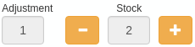
Adjusting stock:
- Adjustment shows what changes you are going to be making to the stock. When it says 5, that means you are increase the stock for that item by 5. If it says 0, that means no changes to the stock are being made.
- Stock will show the actual number in real time of the stock for that particular item. Increase or decreasing the stock will change this number. The Adjustment number and Stock numbers are linked together. In the example image, the Adjustment number is 1, and the Stock is 2. This means you are increase the stock by +1 which will set the new Stock total to 2.
- Depending on which scanning adjustment mode you are in, when you scan / beep a item, it will perform different functions.
  - Stock adjustment + mode will increase the adjustment value by 1 each time you scan / beep a item.
  - Stock adjustment - mode will decrease the adjustment value by 1 each time you scan / beep a item.
  - Stock adjustment (aka: Check stock mode) will not adjust the stock
- Manual adjustment. Touch the + or - buttons to manually increase or decrease the stock.

Saving changes to a individual item:
- Touch the Green Check button.
  - This will save the individual item and update it’s stock numbers. Any changes you made to this item will be applied. The item will be removed from the list after saving and appear in the scan history.

Saving all changes:
- Touch the Save All button.
  - This will save all changes made to all items that are in the list. They will be removed from the list and appear in your scan history.
Step 4 --> Scan Save History
The scan save history shows all your previous scanning updates that were saved to the database during your scanning session. This may be useful in case you forget which items you previous updated during your scanning session.
